**FeaturedCarddetails.jsx**

import React, { useState } from "react";

import { useParams } from "react-router-dom/cjs/react-router-dom.min";

import { Link } from "react-router-dom";

import "./Featured.css";

import RecentCard3 from "../recent/RecentCard3";

const FeaturedCarddetails = () => {

const { id } = useParams();

const [showRecentCard, setShowRecentCard] = useState(true);

const [paragraphContent, setParagraphContent] = useState(id);

const handleclose = () => {

setShowRecentCard(false);

setParagraphContent("");

};

return (

<div>

<div className="row-container">

<div className="row-sub">

<input type="text" placeholder="Requirements" class="search-input" />

<img

src="https://i.pinimg.com/736x/d8/24/49/d824497bfa8c216abf97ac8f593bf81d.jpg"

alt="background-img"

class="chamkchalo"

/>

</div>

<select name="values" class="custom-select">

<option value="Choose">{id}</option>

<option value="Recently added">Recently added</option>

<option value="Older">Older</option>

<option value="Price min-max">Price min-max</option>

<option value="Price max-min">Price max-min</option>

</select>

</div>

{/* <div className='onClofilter'>

<button type="button" class="btn-close" aria-label="Close">X</button>

<p style={{fontSize:"14px"}}>{id}</p>

</div> */}

<div className="styBox">

<Link to="/services">

<button onClick={handleclose}>X</button>

</Link>

<p style={{ margin: "5px 8px" }}>{paragraphContent}</p>

</div>

{showRecentCard && (

<div style={{ margin: "20px 110px" }}>

<RecentCard3 id={id} />

</div>

)}

</div>

);

};

export default FeaturedCarddetails;

**Featured.css**

.featured .box {

box-shadow: 0 0 20px 0 rgb(112 121 138 / 18%);

border-radius: 6px;

text-align: center;

padding: 30px;

cursor: pointer;

}

.featured img {

width: 65px;

height: 65px;

margin: auto;

}

/*FEATURED CARD DETAILS CSS*/

.row-container {

display: flex;

justify-content: space-between;

align-items: center;

padding: 20px;

}

.row-sub {

display: flex;

justify-content: space-between;

align-items: center;

}

.search-input {

padding: 10px;

font-size: 16px;

border: 1px solid #ccc;

border-radius: 4px;

width: 200px;

}

.chamkchalo {

margin-left: 10px;

height: 120px;

width: 160px;

transform-origin: left center;

transition: transform 5.2s;

}

.chamkchalo:hover {

transform: scaleX(5.8);

}

/* .onClofilter{

display: flex;

flex-direction: row;

justify-content: space-between;

border: 1px solid #ccc;

background-color: whitesmoke;

color: rgb(109, 176, 221);

width: 200px;

padding: 10px;

border-radius: 5px;

margin: 0 20px;

} */

.styBox {

width: 17%;

padding: 0.75rem;

margin-left: 0.75rem;

border-radius: 5px;

color: rgb(118, 92, 179);

background: white;

border: 1px solid rgb(118, 92, 179);

display: flex;

flex-direction: row;

justify-content: center;

}

.btn-close1:hover {

cursor: pointer;

}

.custom-select {

padding: 10px;

font-size: 16px;

border: 1px solid #ccc;

border-radius: 4px;

width: 150px;

}

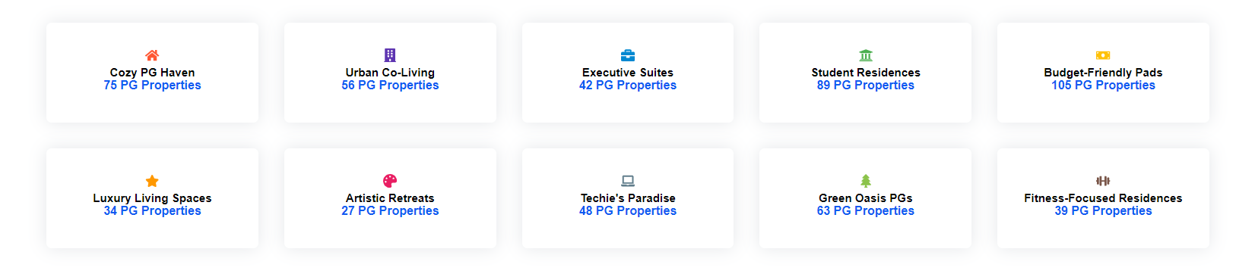

Currently we r on service page after clicking Executive Suites.

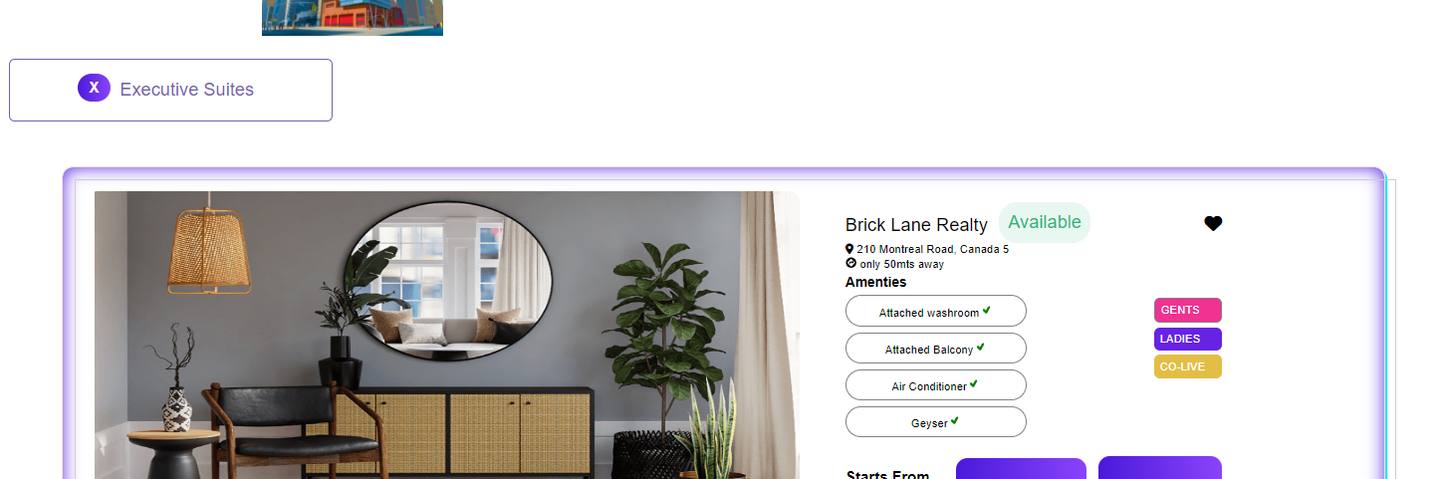

It redirect to that page when we click on x cross button.

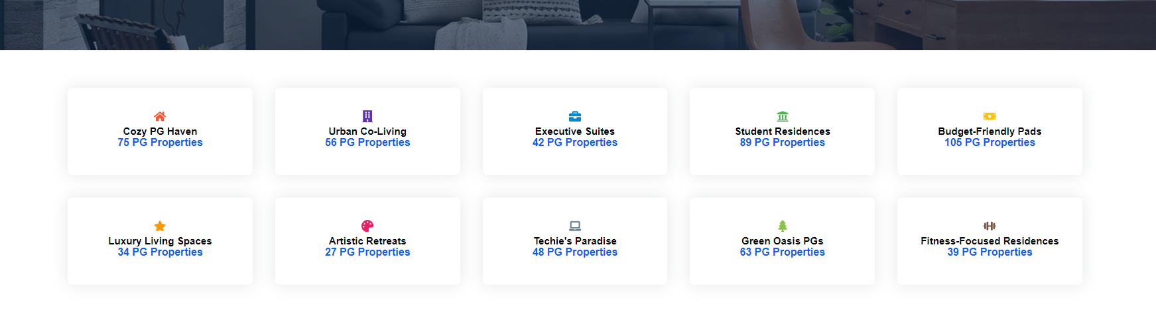

It redirect to service page.